Software Requirements Specification for:
Student attendance tracking system
Version V4
Prepared by Hlib Bokatov
Lodz university of technology
13.04.2026

Table of Contents
Contents
1. Introduction 3
1.1. Purpose 3
1.2. Document Conventions 3
1.3. Intended Audience and Reading Suggestions 3
1.4. Product Scope 3
2. Overall Description 4
2.1. Product Perspective 4
2.2. Product Features 4
2.3. User Classes and Characteristics 4
2.4. Operating Environment 4
2.5. Design and Implementation Constraints 4
2.6. Assumptions and Dependencies 5
2.7. UML Class Diagram 5
3. System Features 6
3.1. Use Case Diagram 6
3.2. User Authentication 6
3.3. Attendance Marking 6
3.4. Attendance Overview 6
3.5. Report generation 6
4. External Interface Requirements 7
4.1. User Interfaces Overview 7
4.2. Hardware Interfaces 7
4.3. Software Interfaces 7
5. System Features/Modules 7
5.1.1 Description and Priority 7
5.1.2 Stimulus/Response Sequences 7
5.1.3. Activity Diagram 8
5.1.4 Functional Requirements 8
6. Nonfunctional Requirements 8
6.1. Performance 8
6.2. Security 8
7. GitHub repository 9

Revision History

Name | Date | Reason for Changes | Version
Hlib Bokatov | 03.03.2026 | Initial version | V1
Hlib Bokatov | 15.03.2026 | Added Use case Diagram | V2
Hlib Bokatov | 24.03.2026 | Added UML Class Diagram | V3
Hlib Bokatov | 13.04.2026 | Added Activity Diagram | V4

1. Introduction

1.1. Purpose
This document specifies the software requirements for student attendance tracking system. This software is designed for automation attendance tracking for university classes

1.2. Document Conventions
Requirements are labelled as:
- FR-xx – for functional requirements
- NFR-xx – for non-functional requirements
All mandatory requirements use the word “shall”

1.3. Intended Audience and Reading Suggestions
This document is intended for:
- Developers – to implement features
- Testers – to verify system correctness
- University administration – to validate requirements
Recommended reading order:
- Introduction
- Overall Description
- System Features
- External Interface Requirements
- System Features/Models
- Non-functional Requirements

1.4. Product Scope
The Students Attendance Tracking System is a web-based application that allows:
- Teachers to mark attendance digitally
- Students to monitor their attendance percentage
- Automatic eligibility calculation for exams
- Generation of attendance reports
The system replaces manual paper-based attendance registers and improves accuracy and accessibility

2. Overall Description

2.1. Product Perspective
Students Attendance Tracking System is a new web application that shall integrate with the university’s existing student information system. It shall use a secured database to store the attendance records

2.2. Product Features

The system shall provide:
- User authentication (Student, teacher, admin)
- Attendance marked by teachers
- Attendance percentage calculator
- Eligibility determination for exams
- Attendance report export (PDF)
2.3. User Classes and Characteristics
The main user classes of the system are:
- Students - the largest user group. They log in to check their attendance, view their percentage per course, and see whether they are eligible for the final exam.
- Teachers - use the system regularly during classes to mark student attendance, edit records when needed, and export reports. They need a simple and fast interface because attendance is usually marked at the beginning of the class.
- Administrators - manage user accounts, courses, and system configuration. This is the smallest group but has the highest privilege level.
Students and teachers are the most important user classes to satisfy, since they interact with the system daily

2.4. Operating Environment
The system shall operate in the following environment:
- Server side: Linux-based server, running a Node.js runtime and a PostgreSQL database.
- Client side: any modern web browser (Chrome, Firefox, Edge, Safari) on desktop or mobile devices.

2.5. Design and Implementation Constraints
- All communication between the client and server shall be encrypted via HTTPS.
- The system shall be implemented as a web application (no native mobile app in this version).
- PostgreSQL shall be used as the database engine.
- Source code shall follow clean code principles and be maintained in a Git repository.

2.6. Assumptions and Dependencies
- It is assumed that the university provides a stable internet connection and a hosting environment for the system.
- It is assumed that each student and teacher has a valid university account.
- Any change in the university's authentication system may require adjustments on the side of this application.

2.7. UML Class Diagram
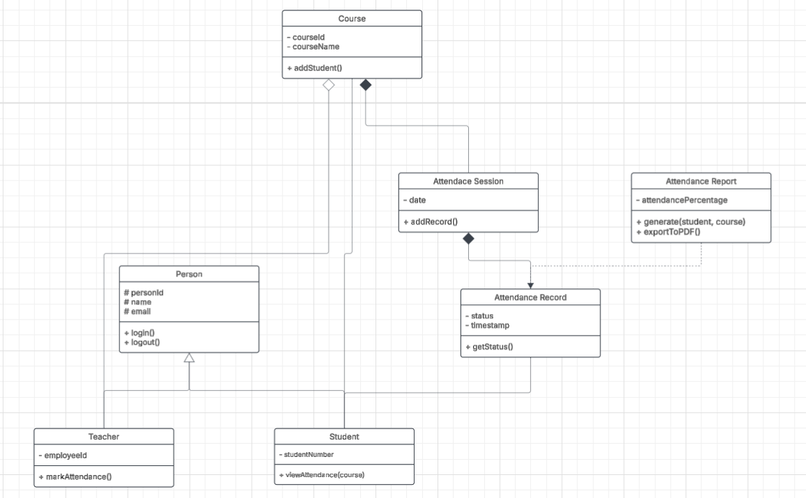
Figure 1. UML Class Diagram

3. System Features

3.1. Use Case Diagram
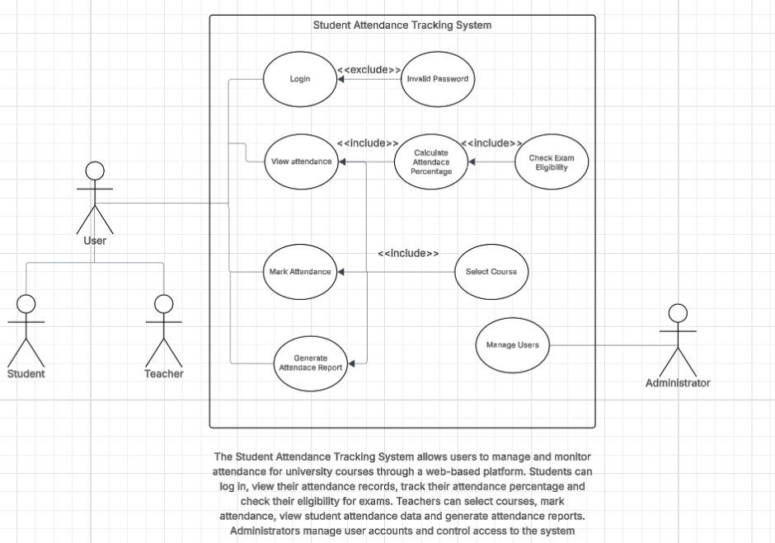
Figure 2. Use Case diagram

3.2. User Authentication
Allows students, teachers, and administrators to log in with their university credentials and access features according to their role.

3.3. Attendance Marking
Allows teachers to mark students as present, absent, or justified during classes and save the results to the database.

3.4. Attendance Overview
Allows students to view their attendance percentage per course and check if they meet the eligibility threshold for the exam.

3.5. Report generation

4. External Interface Requirements

4.1. User Interfaces Overview

4.2. Hardware Interfaces

4.3. Software Interfaces

5. System Features/Modules

5.1.1 Description and Priority

5.1.2 Stimulus/Response Sequences

5.1.3. Activity Diagram
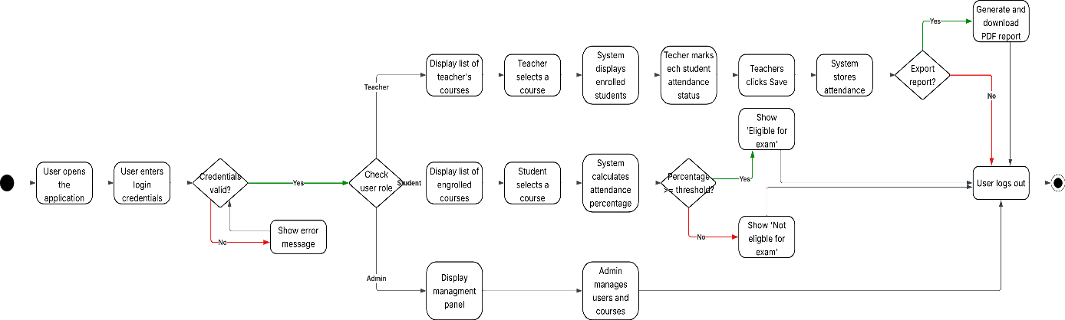
Figure 3. Activity Diagram

5.1.4 Functional Requirements
FR-1.1: When entering valid login credentials the system shall authenticate the user and allow access to the system
FR-1.2: When entering invalid login credentials, the system shall display an error message and deny access
FR-1.3: The system shall differentiate user roles (student or teacher) and display the appropriate content
FR-1.4: The system shall allow users to log out of the system securely
FR-1.5: When entering valid login credentials, the system shall authenticate the user and allow access to the system
FR-1.6: When selecting a course, the system shall display the list of students enrolled in that course
FR-1.7: The system shall store attendance records in the database after submission
FR-1.7: The system shall allow the teacher to mark students as present, absent or justified

6. Nonfunctional Requirements

6.1. Performance
NFR-1.1: The system shall respond to user requests withing 2 seconds under normal operating conditions
NFR-1.2: The system shall support at least 200 simultaneous users without performance drop

6.2. Security
NFR-2.1: The system shall require user authentication before accessing private data
NFR-2.2: The system shall restrict access to modifying attendance to authorized teachers only

7. GitHub repository

